**Digital Signage OpenNI2 Driver Installation Instructions**

**V0.1.0**

**GIGA-BYTE TECHNOLOGY CO. LTD. Company:**

**Sign: Sign:**

**Date: Date:**

# Revision History

|  |  |  |  |  |
| --- | --- | --- | --- | --- |
| **Rev** | **Modification Descriptions** | **Date** | **Editor** | **Approver** |
| 0.1.0 | Initial version  Release x64 Windows version only | April 11, 2019 | KKPoon |  |

# Table of Contents

Revision History 2

Table of Contents 3

1. Voxel SDK 4

1.1. Install Voxel SDK for x86 architecture Windows 4

1.2. Install Voxel SDK for x64 architecture Windows 9

1.3. Install Voxel SDK for i386 architecture Ubuntu 16.04 14

1.4. Install Voxel SDK for amd64 architecture Ubuntu 16.04 14

2. OpenNI2 Driver 15

2.1. Run OpenNI2 Driver for x86 architecture Windows 15

2.2. Run OpenNI2 Driver for x64 architecture Windows 16

2.3. Run OpenNI2 Driver for i386 architecture Ubuntu 16.04 17

2.4. Run OpenNI2 Driver for amd64 architecture Ubuntu 16.04 18

2.5. Develop your own OpenNI2 application with GIGABYTE camera 19

# Voxel SDK

## Install Voxel SDK for x86 architecture Windows

1. Run Windows/VoxelSDK/x86/SDK-x.x.x-win32.exe(where the “x.x.x” stands for version number)

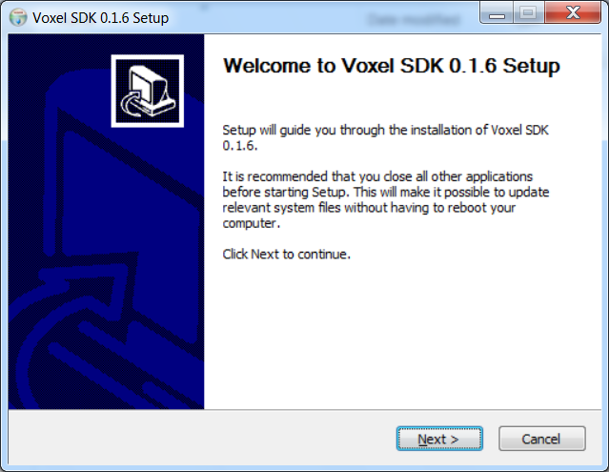

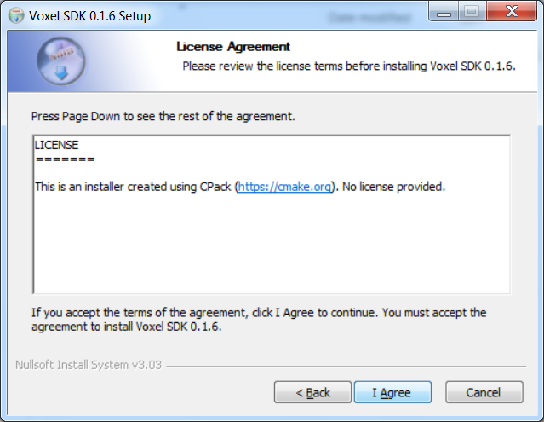

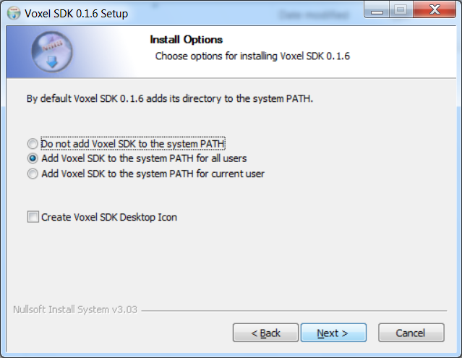

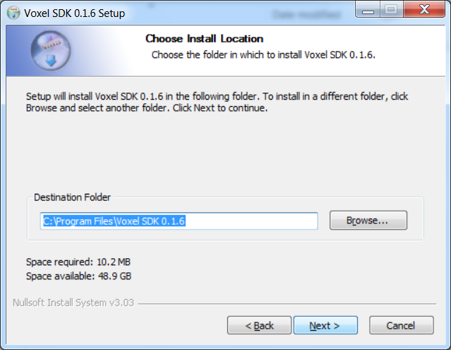

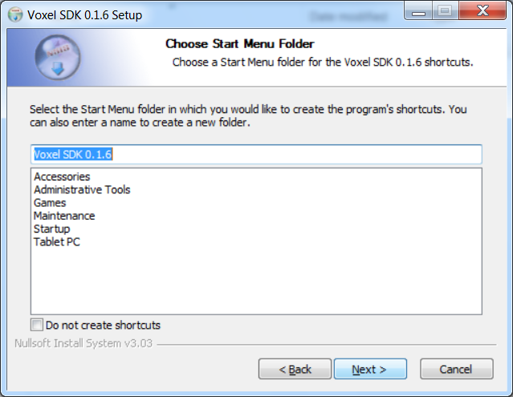

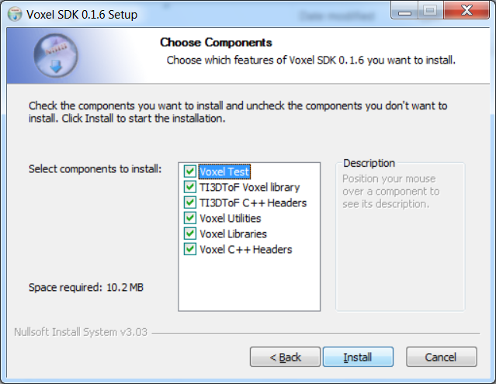

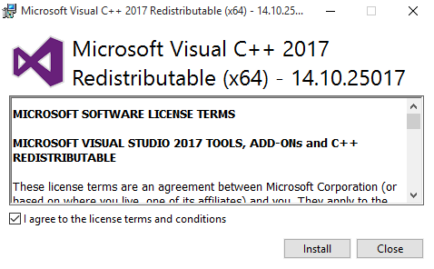

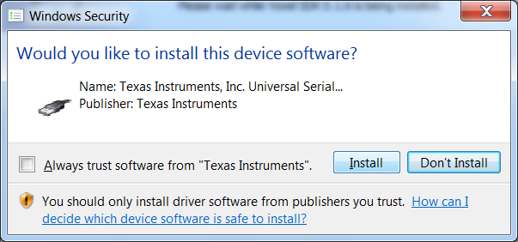

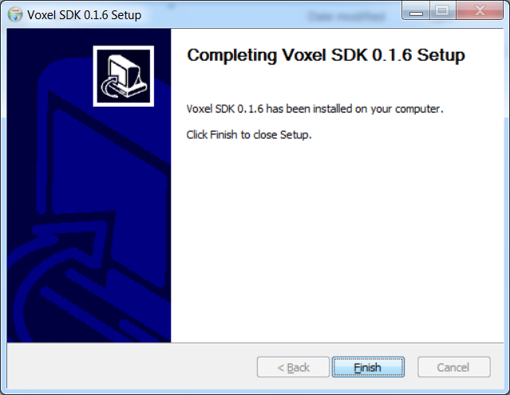

1. Reboot PC

## Install Voxel SDK for x64 architecture Windows

1. Run Windows/VoxelSDK/x64/SDK-x.x.x-win64.exe(where the “x.x.x” stands for version number)

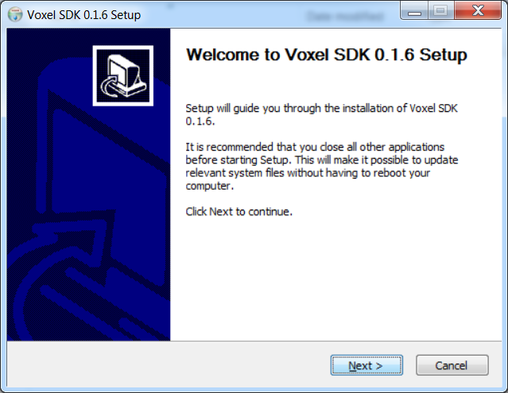

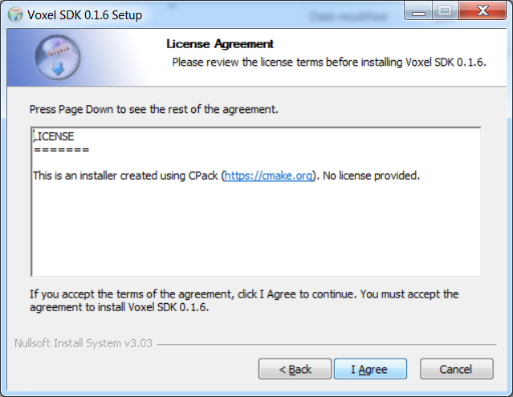

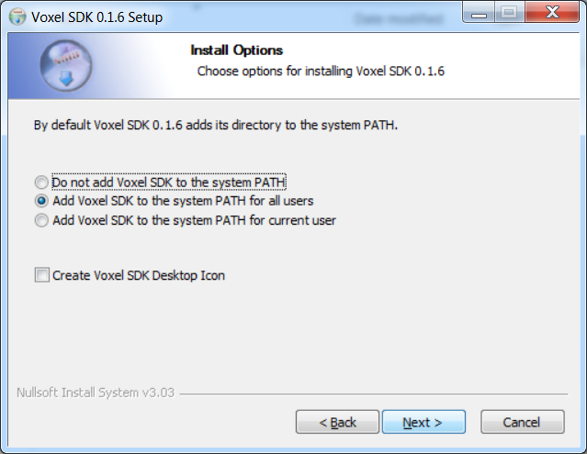

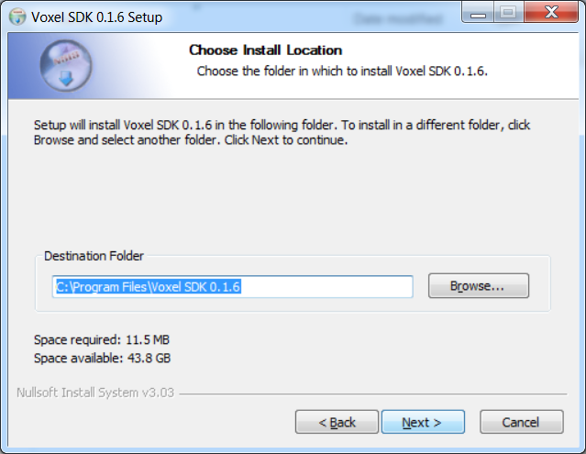

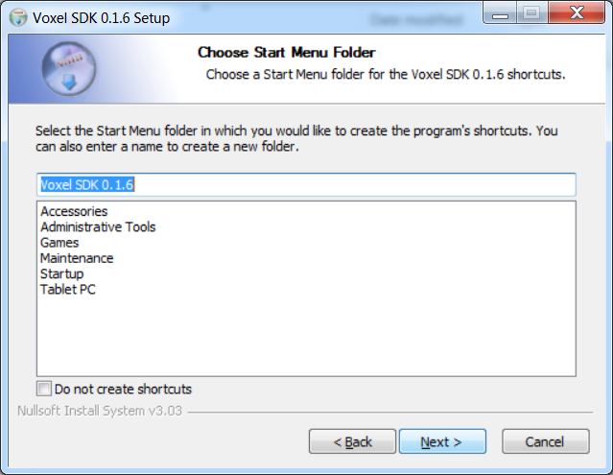

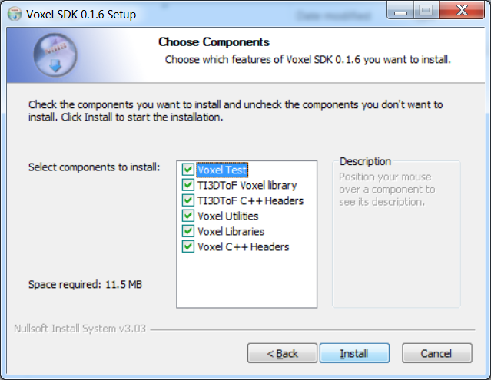



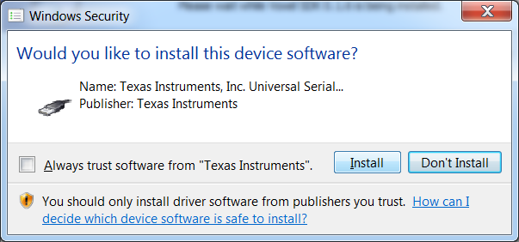

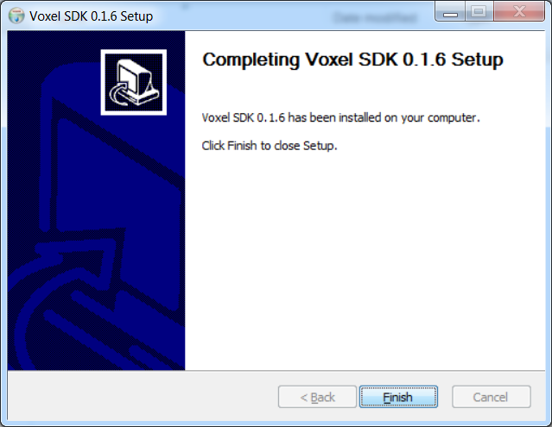

1. Reboot PC

## Install Voxel SDK for i386 architecture Ubuntu 16.04

1. Install the Debian packages(where the “x.x.x” stands for version number)
   * + - libti3dtof-x.x.x-i386-xenial.deb
       - libti3dtof-dev-x.x.x- i386-xenial.deb
       - libvoxel-x.x.x- i386-xenial.deb
       - libvoxel-dev-x.x.x- i386-xenial.deb
       - libvoxel-test-x.x.x- i386-xenial.deb

sudo apt-get install libusb-1.0-0-dev libudev-dev linux-libc-dev

cd Linux/VoxelSDK/x86

sudo dpkg -i *.deb

* + - * libvoxel-util-x.x.x- i386-xenial.deb

## Install Voxel SDK for amd64 architecture Ubuntu 16.04

1. Install the Debian packages(where the “x.x.x” stands for version number)
   * + - libti3dtof-x.x.x-amd64-xenial.deb
       - libti3dtof-dev-x.x.x-amd64-xenial.deb
       - libvoxel-x.x.x-amd64-xenial.deb
       - libvoxel-dev-x.x.x-amd64-xenial.deb
       - libvoxel-test-x.x.x-amd64-xenial.deb

sudo apt-get install libusb-1.0-0-dev libudev-dev linux-libc-dev

cd Linux/VoxelSDK/x64

sudo dpkg -i *.deb

* + - * libvoxel-util-x.x.x-amd64-xenial.deb

# OpenNI2 Driver

## Run OpenNI2 Driver for x86 architecture Windows

1. Run Windows/OpenNI2/x86/NiViewer.exe
2. If everything is correct, you can see the image from camera

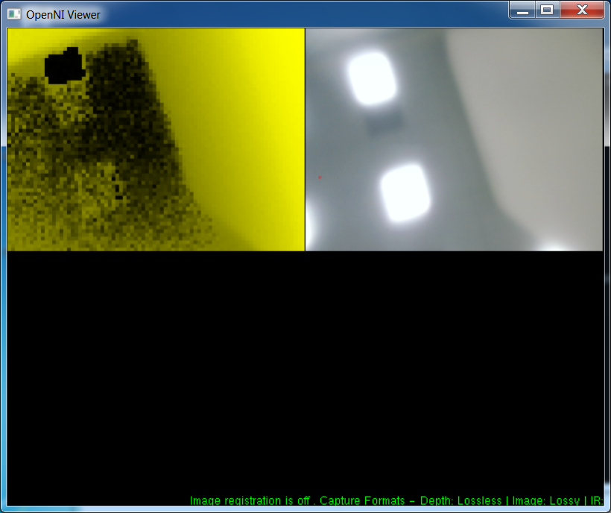

## Run OpenNI2 Driver for x64 architecture Windows

1. Run Windows/OpenNI2/x64/NiViewer.exe
2. If everything is correct, you can see the image from camera

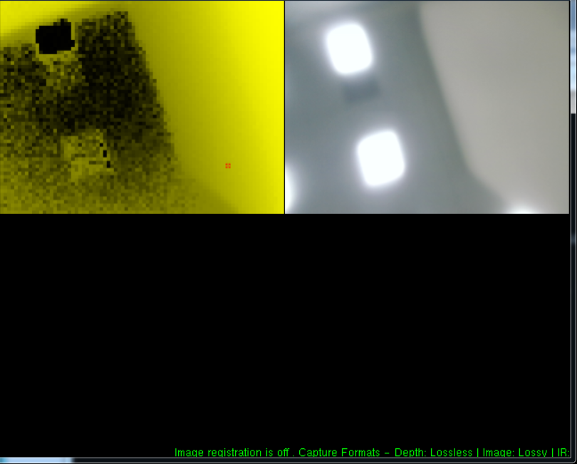

## Run OpenNI2 Driver for i386 architecture Ubuntu 16.04

sudo apt-get install freeglut3

cd Linux/OpenNI2/x86

./NiViewer

1. Run Linux/OpenNI2/x86/NiViewer
2. If everything is correct, you can see the image from camera

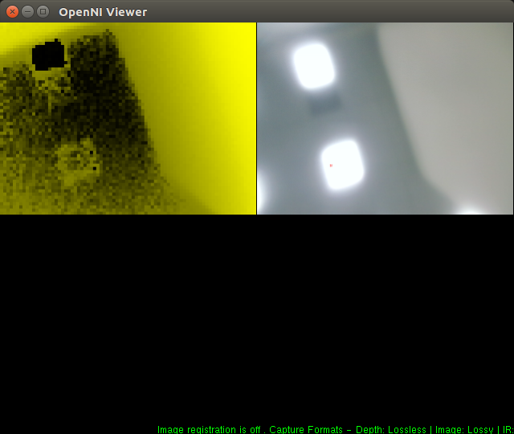

## Run OpenNI2 Driver for amd64 architecture Ubuntu 16.04

sudo apt-get install freeglut3

cd Linux/OpenNI2/x64

./NiViewer

1. Run Linux/OpenNI2/x64/NiViewer
2. If everything is correct, you can see the image from camera

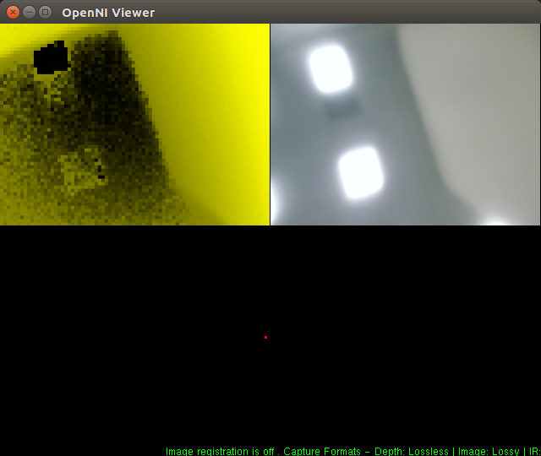

## Develop your own OpenNI2 application with GIGABYTE camera

1. Download and install [OpenNI2 SDK](https://structure.io/openni)
2. Setup OpenNI2 development environment to your application
3. Copy GB_DepthCamera.dll or libGB_DepthCamera.so to “/OpenNI2/Drivers/” folder at directory of your application depend on your platform
4. Run your application